**Lesson 20 Cíntia Domingos**

**Beet Seed**

**2.**

**3.**

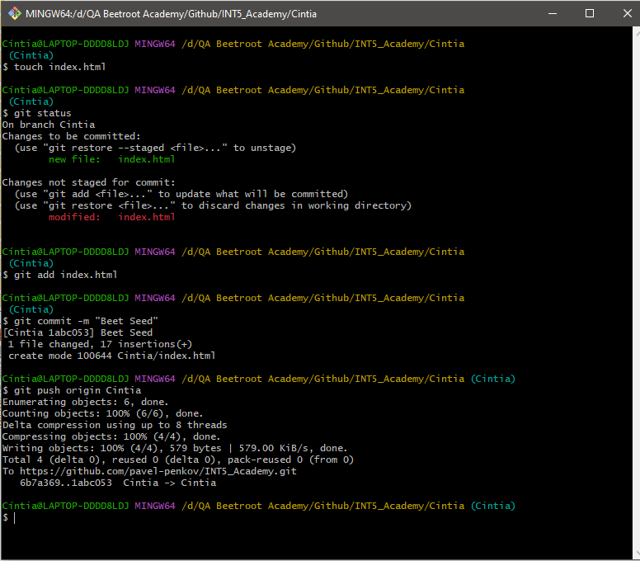

4.

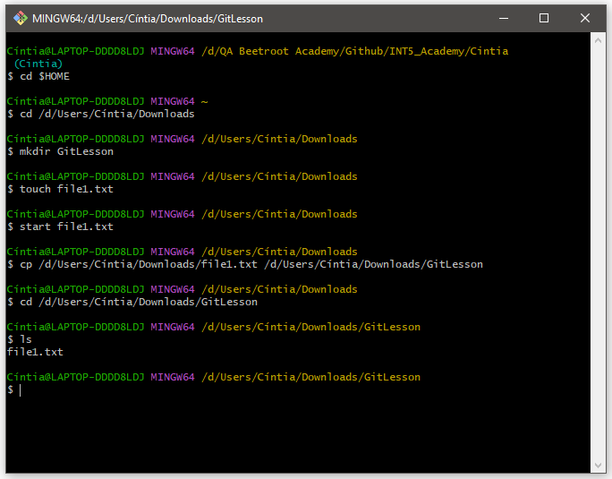

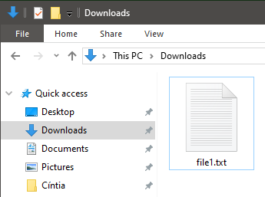

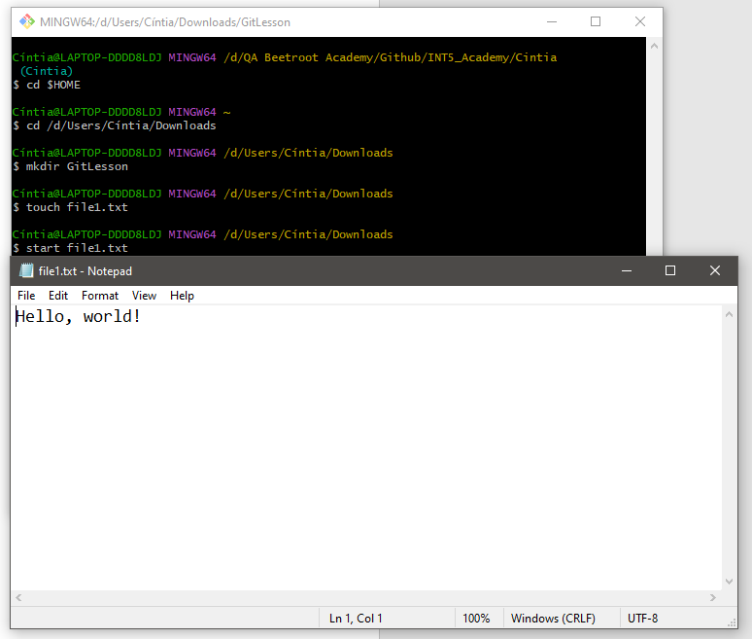

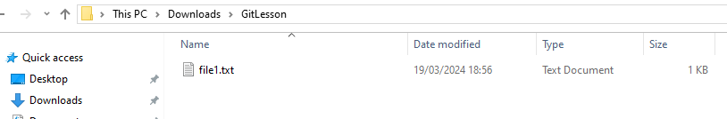

**Beet Sprout**

**2.**

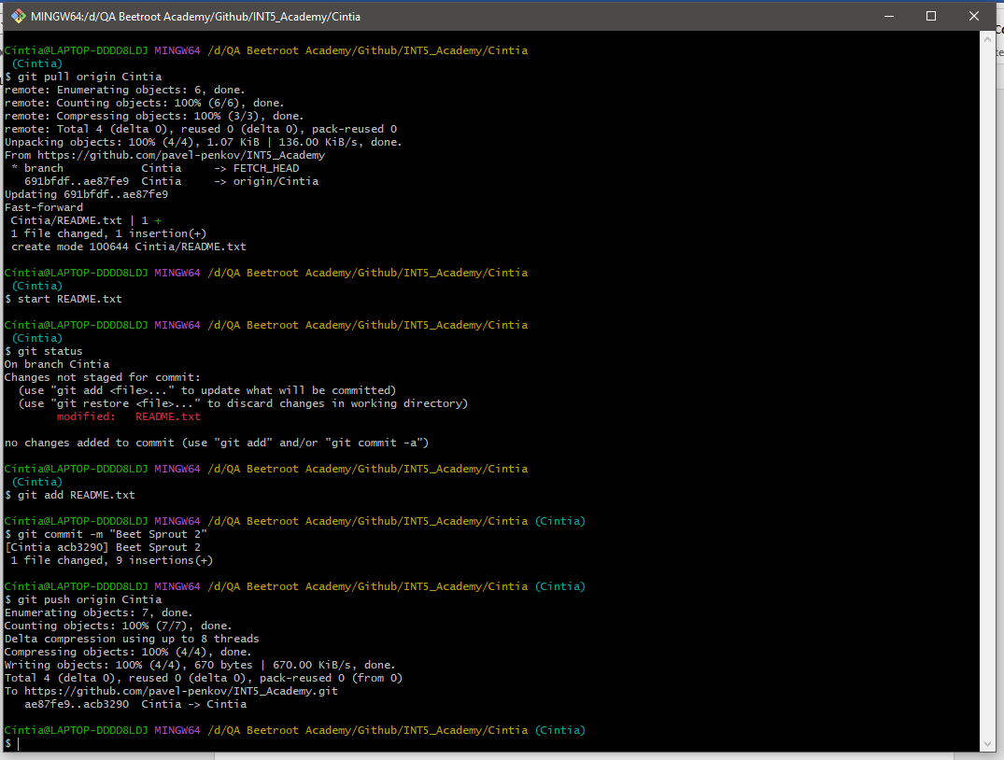

**3.**

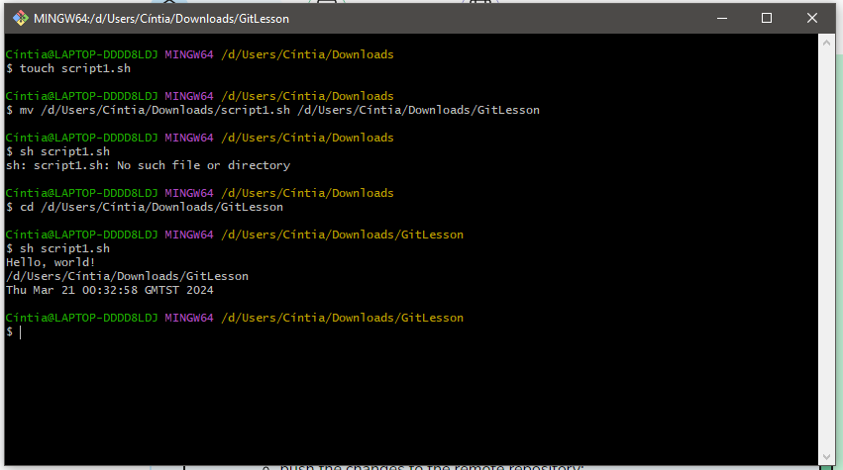

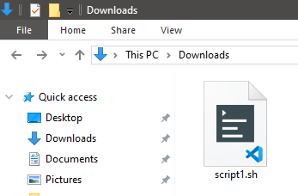

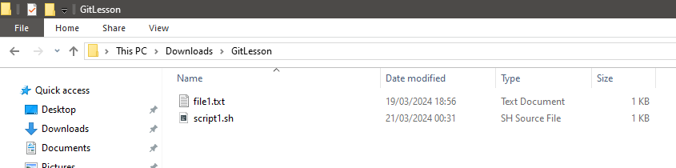

**Mighty Beet**

**2.**

New branch:



I changed the name of a local file and pushed it to the remote repo, which created a new remote file, but left the original one there. I had some trouble trying to delete it from the remote repository. I ended up deleting the folder and everything in it:

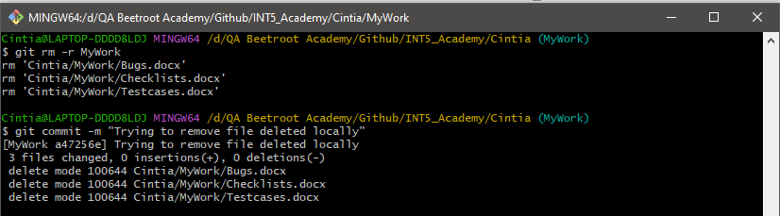

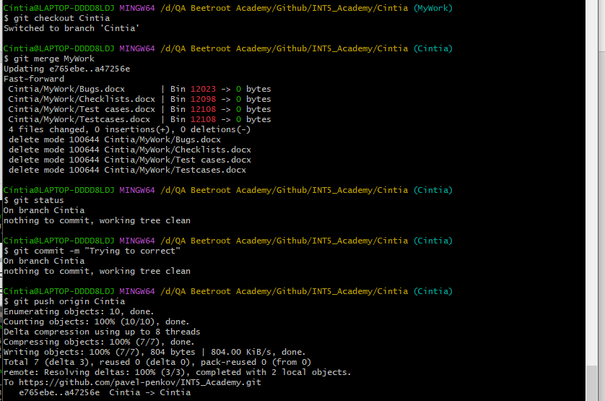

And doing everything again:

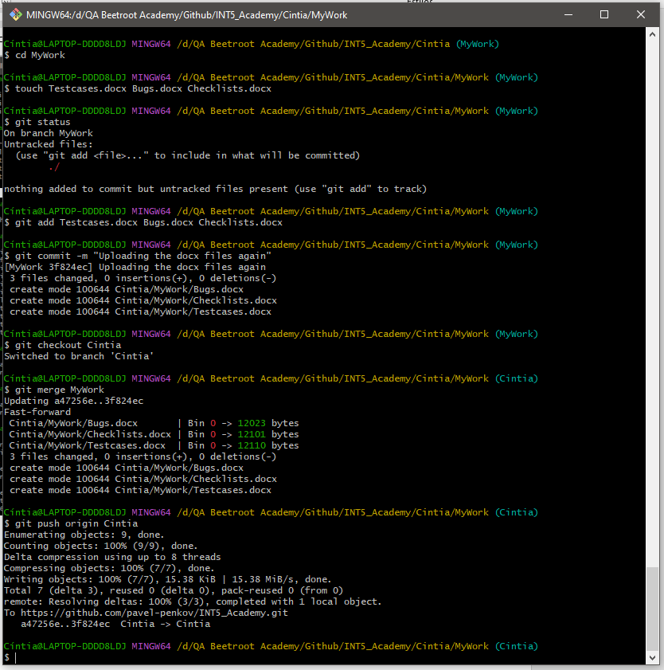

I also created a .md file in Visual Studio Code for the README:

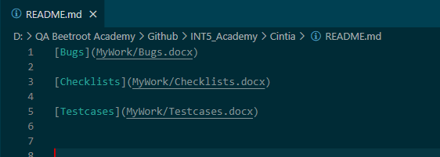

**3.**

